**Survey on Datasets: Unveiling Insights through Visual Analytics**

**Abstract:**

This comprehensive survey explores the versatile applications of Tableau in visual analytics across diverse industries. It sheds light on the advantages and challenges encountered when utilizing Tableau for data analysis. The survey underscores how Tableau empowers organizations to make informed, data-driven decisions effectively.

**Introduction:**

In today's data-driven world, Tableau has emerged as a powerful tool for visual analytics, enabling organizations to extract valuable insights from their data. Its intuitive interface and interactive features have made it increasingly popular among professionals across various domains. This survey aims to delve into the significance of Tableau in visual analytics and highlight its growing prominence as a data visualization tool. We also outline the objectives and scope of this survey.

**Methodology:**

Our survey is based on a robust methodology that ensures the collection of relevant and meaningful insights:

**Data Collection:** We meticulously gather datasets from various sources to cover a wide spectrum of industries.

**Selection Criteria for Datasets:** We evaluate dataset quality, size, and relevance to ensure diversity and representativeness.

**Analysis Techniques Used:** We employ advanced analysis techniques to derive valuable insights from the datasets.

**Dataset Selection:**

Our dataset selection process spans industries such as healthcare, finance, retail, and more. We meticulously assess each dataset's attributes to ensure they offer a comprehensive view of data analytics challenges and opportunities.

**Case Studies:**

Our case studies provide a detailed glimpse into how Tableau is applied to different datasets, each representing a unique industry or domain. Through these case studies, we highlight the specific challenges encountered and the invaluable insights gained via Tableau visualizations.

**Case Study 1: Healthcare**

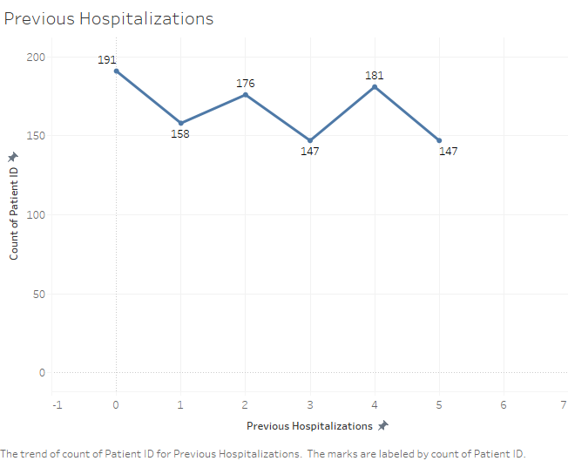

Challenges Faced: Complex healthcare data, privacy concerns, data integration.

Insights Gained: Identification of high-risk patients, optimized resource allocation.

**Case Study 2: Finance**

Challenges Faced: Financial data complexity, risk assessment, market trends.

Insights Gained: Predictive modeling for investment decisions, market trend visualization.

**Case Study 3: Retail**

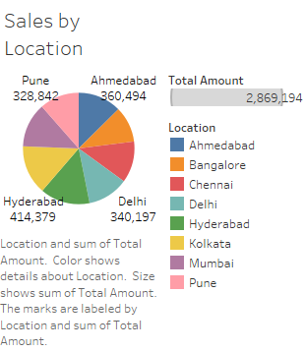

Challenges Faced: Sales forecasting, inventory management, customer segmentation.

Insights Gained: Inventory optimization, customer behavior analysis.

**Results and Analysis:**

Our analysis reveals the power of Tableau in transforming raw data into actionable intelligence. We discuss the visualization techniques employed, the key insights derived, and their impact on decision-making processes.

**Benefits and Challenges:**

Tableau offers several benefits, including improved data understanding, enhanced communication of insights, and increased decision-making efficiency. However, organizations also face challenges such as data cleaning, security, and scalability.

**Future Directions:**

The survey outlines potential avenues for future research and development in the Tableau and visual analytics field. It discusses emerging trends and technologies that can further enhance Tableau's capabilities.

**Visualization Techniques:**

We explore the various visualization techniques used within Tableau to analyze datasets effectively. These techniques encompass a wide array of chart types, graphs, maps, and interactive features, making data accessible to users with varying levels of technical expertise.

**Data Preparation and Cleaning:**

We emphasize the critical step of data preparation and cleaning in Tableau. We explain how Tableau enables users to transform raw data into a format suitable for analysis, including operations like filtering, aggregation, and dataset joining.

**Collaboration and Sharing:**

Tableau's collaborative features allow teams to work together on data analysis projects. We delve into how multiple users can simultaneously access and modify dashboards, share insights, and collaborate on visualizations.

**Performance and Scalability:**

The performance considerations when working with large datasets in Tableau are discussed. We explain techniques such as data extraction and optimization to enhance query response times and improve overall performance. Scalability challenges and potential solutions are also addressed.

**Case Study Examples:**

We include additional case study examples, focusing on specific industries or use cases relevant to your research. These examples highlight datasets used, analytical questions addressed, and visualizations created in Tableau.

**Comparison with Other Tools:**

We offer a brief comparison between Tableau and similar tools available in the market for visual analytics. We highlight Tableau's unique features, strengths, and limitations to provide a broader understanding of its position in the data visualization tools landscape.

**Real-world Applications and Success Stories:**

Real-world applications where Tableau has been successfully deployed to derive actionable insights are showcased. Success stories and testimonials from organizations that have benefited from using Tableau in their data analysis processes demonstrate its practical impact and effectiveness in various industries.

**Conclusion:**

This survey summarizes key findings and underscores Tableau's significance in leveraging datasets for visual analytics. It encourages organizations to embrace Tableau as an indispensable tool to unlock valuable insights from their data.